Monthly Environmental Data April 2014
Contents Page

Air Quality

High Volume Air Samplers (HVAS)

Tapered Element Oscillation Microbalance Sampling (TEOM)

Dust Deposition Sampling

Blasting (Vibration and Overpressure)

Noise

Water

Ground Water

Surface Water

Weather

Data Log

Correction Log

Air Quality

High Volume Air Samplers
Note: A number of errors have been identified in the air emission data. BHOP has engaged consultants Pacific? to review the data and data will be updated following this review.
EPL10 - Silver Tank - ON Site
DATE | TSP (µg/m³) | Lead (µg/m³)
5/04/2014 | 11 | 0.11
11/04/2014 | 15 | 0.17
17/04/2014 | 28 | 0.20
23/04/2014 | 9 | 0.16
29/04/2014 | 4 | 0.20

EPL11 - Silver Tank - On Site
DATE | PM10 (µg/m³) | Lead (µg/m³)
5/04/2014 | 16.5 | 0.1
11/04/2014 | 2.1 | 0.1
17/04/2014 | 7.1 | 0.1
23/04/2014 | 7.0 | 0.1
29/04/2014 | 8.0 | 0.1

EPL12 - Blackwoods Pit – On Site
DATE | PM10 (µg/m³) | Lead (µg/m³)
5/04/2014 | 12.80 | 0.26
11/04/2014 | 4.11 | 0.05
17/04/2014 | 5.83 | 0.08
23/04/2014 | 3.87 | 0.08
29/04/2014 | 14.82 | 0.08

Tapered Element Oscillating Microbalance Sampling (TEOM)

Particulate Matter <10 Microns 24Hr Average
Date | TEOM 1 - EPL 13 (μg/m³)  Essential Water – Off Site | TEOM 2 – EPL 14 (μg/m³)  Blackwoods Pit – On Site
1/04/2014 | 16.49 | 7
2/04/2014 | 16.8 | 9.58
3/04/2014 | 13.14 | NoData (Invalid)  Machine Down during this period for unknown reasons.  Consultant engaged and booked for 14/05/2014 to complete repairs.
4/04/2014 | 11.45 | NoData (Invalid)
5/04/2014 | 14.79 | NoData (Invalid)
6/04/2014 | 16.9 | NoData (Invalid)
7/04/2014 | 7.75 | NoData (Invalid)
8/04/2014 | 4.39 | NoData (Invalid)
9/04/2014 | 14.65 | NoData (Invalid)
10/04/2014 | 8.12 | 5.72
11/04/2014 | 7.23 | 8.37
12/04/2014 | 6.95 | 12.83
13/04/2014 | 7.85 | 12.7
14/04/2014 | 9.09 | 16.09
15/04/2014 | 10.15 | 19.64
16/04/2014 | 11.17 | 19.05
17/04/2014 | 13.65 | 15.83
18/04/2014 | 18.71 | 16.99
19/04/2014 | 15.95 | 18.46
20/04/2014 | 19.86 | 19.81
21/04/2014 | 17.08 | 17.58
22/04/2014 | 15.67 | 16.02
23/04/2014 | 14.61 | NoData (Invalid)  Machine began to work again on the 10th April 2014 however failed again on the 23rd April 2014.  Consultant engaged and booked for 14/05/2014 to complete repairs.
24/04/2014 | 13.58 | NoData (Invalid)
25/04/2014 | 11.31 | NoData (Invalid)
26/04/2014 | 11.96 | NoData (Invalid)
27/04/2014 | 12.49 | NoData (Invalid)
28/04/2014 | 17.64 | NoData (Invalid)
29/04/2014 | 14.03 | NoData (Invalid)
30/04/2014 | 10.88 | NoData (Invalid)

PM10 μg/m³ 12 Month Rolling Average
 | May-13 | Jun-13 | Jul-13 | Aug-13 | Sep-13 | Oct-13 | Nov-13 | Dec-13 | Jan-14 | Feb-14 | Mar-14 | Apr-13
TEOM 1 EPL13  Essential Water  Off Site | 11.0 | 10.1 | 12.0 | 15.1 | 21.2 | 19.6 | 17.8 | 19.9 | 29.2 | 22.7 | 16.0 | 12.8
TEOM 2 EPL14  Blackwoods Pit  On Site | 11.7 | 7.8 | 12.0 | 15.2 | 23.4 | 32.6 | 22.5 | 22.0 | 32.0 | 23.7 | 17.6 | 14.4

EPL13 – Essential Water – Off Site

EPL14 – Blackwoods Pit – On Site
Invalid Data
Invalid Data

SW Winds of up to 81Km/h During the month of October 2013 with an Average Temp of 27˚C .
S Winds of up to 72km/h during the month of January 2014 with an average Temperature of 36˚C
Dust suppression was reapplied during the month of January 2013.

Dust Deposition Sampling
Total Deposited Dust (g/m^{2/}Month)
Date | D1  (off site) | D2 | D3 | D4 | D5 | D6  (off site) | D7
Mar 2014 | 0.17 | 0.11 | 0.34 | 1.53 | 0.79 | 0.23 | 0.40
Background Average | 4.0 | 3.1 | 4.3 | 5.7 | n/a | 5.8 | n/a

Total Deposited Lead (g/m^{2/}Month)
Date | D1  (Off Site) | D2 | D3 | D4 | D5 | D6  (Off Site) | D7
Mar 2014 | 0.002 | 0.002 | 0.002 | 0.002 | 0.001 | 0.001 | 0.002
Background Average | 0.0034 | 0.0045 | 0.0046 | 0.0060 | n/a | 0.0036 | n/a

Blasting (Vibration and Overpressure)
Note:
Vibration is recorded in Peak Particle Velocity (ppv)
Overpressure is recorded in Decibels (dBL)

- During the month of April blasting occurred daily there was a total number of 62 blasts 8 of which were production firings all inside licensing criteria.
- 54 blast were below a ppv of 0.75mm/s and did not trigger an event
- 4 Blasts recorded a ppv of >5mm/s
- 0 Blasts recorded a ppv of >10mm/s
- All overpressure readings were inside limits.
Date / Location | Peak Vibration  (PPV mm/s) | Peak Over Pressure  (dBL)
03/04/2014 | 5.69 | 109.2
V1 | >0.75 | No Event Triggered
V2 | 3.72 | 109.2
V3 | 5.69 | 101.9
04/04/2014 | 0.779 | 88
V1 | >0.75 | No Event Triggered
V2 | >0.75 | No Event Triggered
V3 | 0.779 | 88
07/04/2014 | 8.07 | 101.9
V1 | >0.75 | No Event Triggered
V2 | 5.4 | 98.8
V3 | 7.07 | 101.9
12/04/2014 | 3.84 | 100
V1 | >0.75 | No Event Triggered
V2 | 1.27 | 100
V3 | 3.84 | 100
16/04/2014 | 4.5 | 101.9
V1 | >0.75 | No Event Triggered
V2 | >0.75 | No Event Triggered
V3 | 4.5 | 101.9
19/04/2014 | 4.41 | 103.5
V1 | >0.75 | No Event Triggered
V2 | 1.01 | 94
V3 | 4.41 | 103.5
23/04/2014 | 6.84 | 105.5
V1 | >0.75 | No Event Triggered
V2 | >0.75 | No Event Triggered
V3 | 6.84 | 105.5
27/04/2014 | 5.15 | 104.9
V1 | >0.75 | No Event Triggered
V2 | 1.3 | 94.4
V3 | 5.15 | 104.9

Noise
Note:
- No noise monitoring was scheduled for the month of April 2014
- Last sampled March 2014 by EMM consultants for crusher project approval modification

Water

Ground Water
Note: Awaiting Analysis From Lab.

Water Sample Results March 2014
Date
Sample ID
pH Value (pH)
Electrical conductivity (uS/cm)
Total Dissolved Solids (mg/L)
Hydroxide Alkalinity as CaC03 (mg/L)
Carbonate Alkalinity CaCO3 (mg/L)
Bicarbonate Alkalinity as CaCO3 (mg/L)
Total Alkalinity (mg/L)
Sulphate as SO4 (mg/L)
Chloride (mg/L)
Calcium (mg/L)
Magnesium (mg/L)
Sodium (mg/L)
Cadmium (mg/L)
Manganese (mg/L)
Lead (mg/L)
Zinc (mg/L)
Iron (mg/L)

Groundwater Table
EPA Identification Number | Frequency | Comment
EPL37 | Quarterly | Awaiting Analysis
EPL38 | Quarterly | Awaiting Analysis
EPL39 | Quarterly | Awaiting Analysis
EPL40 | Quarterly | Awaiting Analysis
EPL41 | Quarterly | Awaiting Analysis
EPL42 | Quarterly | Awaiting Analysis
EPL43 | Quarterly | Awaiting Analysis
EPL44 | Quarterly | Awaiting Analysis
EPL45 | Quarterly | Awaiting Analysis
EPL46 | Quarterly | Awaiting Analysis
EPL47 | Quarterly | Awaiting Analysis
EPL48 | Quarterly | Awaiting Analysis
EPL49 | Quarterly | Awaiting Analysis
EPL50 | Quarterly | Awaiting Analysis
EPL51 | Quarterly | Awaiting Analysis
EPL52 | Quarterly | Awaiting Analysis
EPL53 | Monthly | Awaiting Analysis
EPL54 | Monthly | Awaiting Analysis

Surface Water
Insufficient water was available for samples at surface water locations.

Surface Water Table
EPA Identification Number | Frequency | Comment
EPL29 | 2 x Per year when contains water | Insufficient water for sample
EPL30 | 2 x Per year when contains water | Insufficient water for sample
EPL31 | 2 x Per year when contains water | Insufficient water for sample
EPL32 | 2 x Per year when contains water | Insufficient water for sample
EPL33 | 2 x Per year when contains water | Insufficient water for sample
EPL34 | 2 x Per year when contains water | Insufficient water for sample
EPL35 | 2 x Per year when contains water | Insufficient water for sample

Weather Data
Note:
(BHOP – Automatic Weather Station was unavailable for the month of April, repairs are scheduled for June 2014.
The following data was obtained from the Bureau of Meteorology Broken Hill)
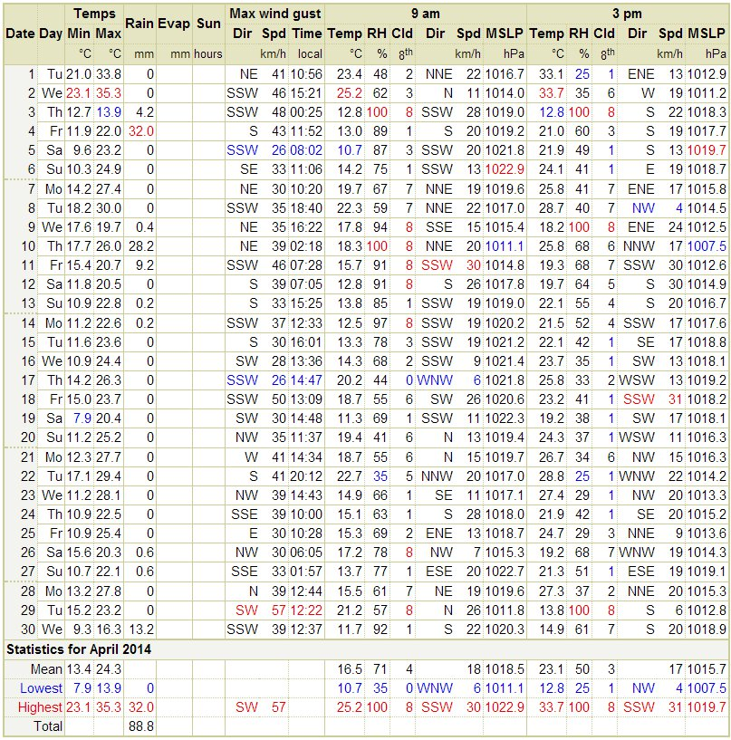
Legend
Dir = Direction, Spd=Wind Speed, Temp=Temperature, RH=Relative Humidity, CLD=Cloud, MSLP=Mean Sea Level Pressure

Data Log
Sample | Date sent to lab | Result Received | Date Published
Hi Volume Samples | 26/05/2014 | 16/06/2014 | 18/06/2014
TEOM | Real time (Downloading Issues) | Corrected by Lear Siegler (14/05/2014) | 18/06/2014
Dust Deposition | 26/05/2014 | 16/06/2014 | 18/06/2014
Water | 30/05/2014 | Awaiting Analysis | 18/06/2014
Blast Vibration and overpressure | Real Time | Real Time | 18/06/2014

Correction Log 1st May 2013 to 31st April 2014
Sample ID# | Date Of Sample | Original Data |  | Corrected Data |  | Date Corrected | Date Originally Published | Reason
EPL10 | 3/06/2013 | TSP | Lead | TSP | Lead | 07/05/2014 | 14/06/2013 | Contamination during analysis at lab
 |  | 52.26 | 2.90 | 52.26 | 0.70
EPL10 | 9/06/2013 | TSP | Lead | TSP | Lead | 07/05/2014 | 14/06/2013 | Contamination during analysis at lab
 |  | 18.99 | 1.43 | 18.99 | 0.24
EPL11 | 3/06/2013 | TSP | Lead | TSP | Lead | 07/05/2014 | 14/06/2013 | Contamination during analysis at lab
 |  | 7.3 | 3.1 | 7.32 | 0.54
EPL11 | 9/06/2013 | TSP | Lead | TSP | Lead | 07/05/2014 | 14/06/2013 | Contamination during analysis at lab
 |  | 10.8 | 2.2 | 10.83 | 0.30
EPL12 | 3/06/2013 | TSP | Lead | TSP | Lead | 07/05/2014 | 14/06/2013 | Contamination during analysis at lab
 |  | 11.43 | 5.05 | 4.35 | 0.52
EPL12 | 9/06/2013 | TSP | Lead | TSP | Lead | 07/05/2014 | 14/06/2013 | Contamination during analysis at lab
 |  | 5.30 | 0.25 | 3.21 | 0.13
EPL12 | 15/06/2013 | TSP | Lead | TSP | Lead | 07/05/2014 | 14/06/2013 | Contamination during analysis at lab
 |  | 2.86 | .024 | 5.36 | 0.13
EPL12 | 21/06/2013 | TSP | Lead | TSP | Lead | 07/05/2014 | 14/06/2013 | Contamination during analysis at lab
 |  | 3.10 | 0.48 | 3.87 | 0.10
EPL12 | 27/06/2013 | TSP | Lead | TSP | Lead | 07/05/2014 | 14/06/2013 | Contamination during analysis at lab
 |  | 3.27 | 0.25 | 9.64 | 0.10

